EXPERIMENT 10 STUDENT DETAILS

Step1: Creating an application called ‘STUDENT INFORMATION’

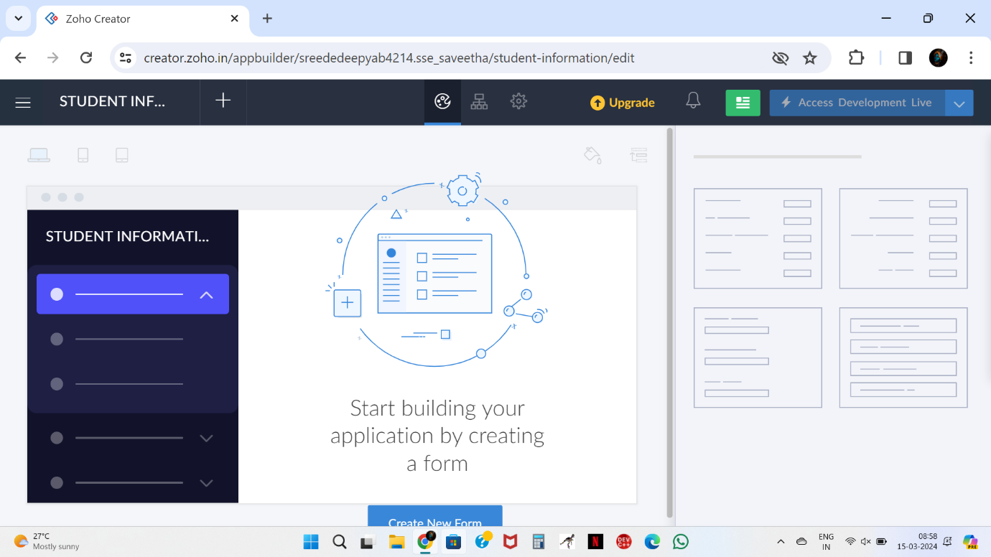

Step2: Create a form called as ‘ Student details ‘

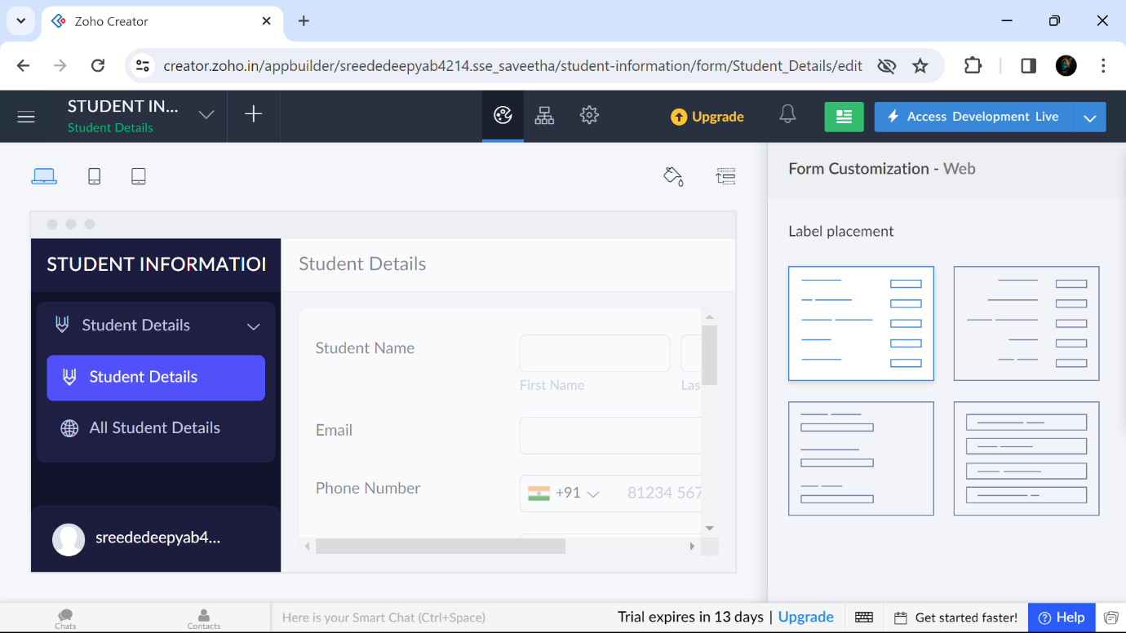

Step3: Create a form called as ‘ Course‘

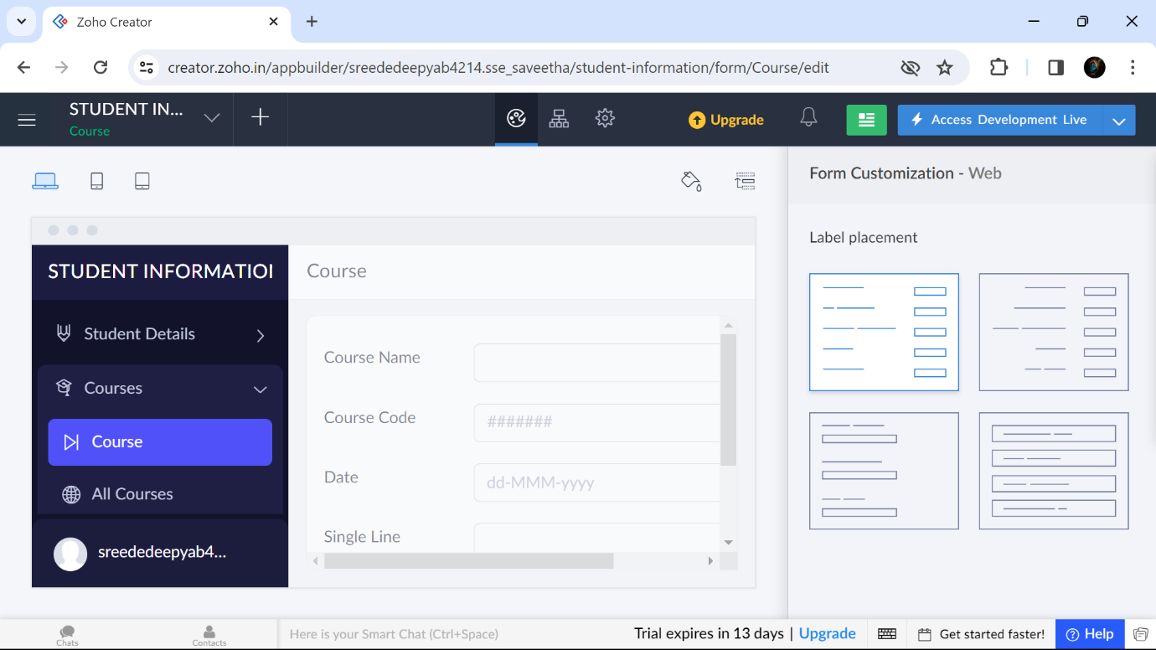

Step4: Create a form called as ‘Attendance’

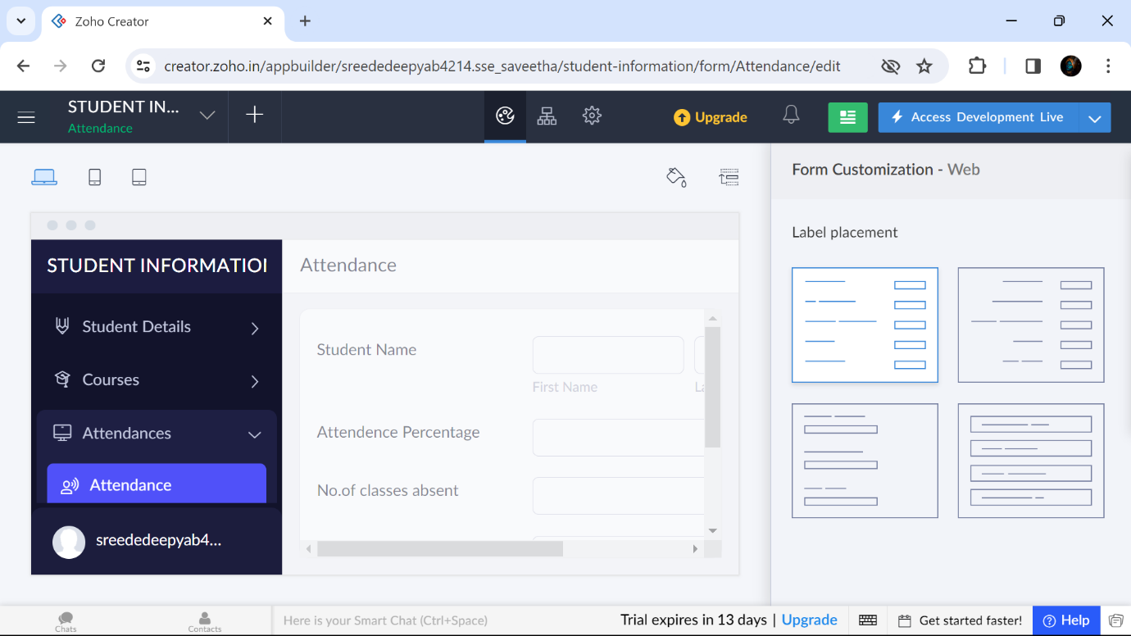

Step 5: Displaying the details entered in ‘Student details’

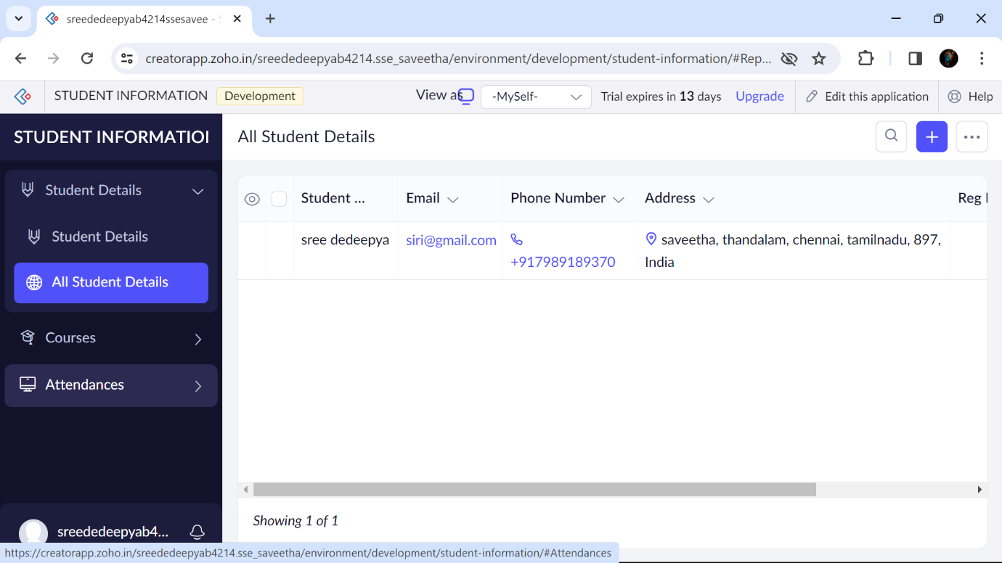

Step 6: Displaying the details entered in ‘Course’

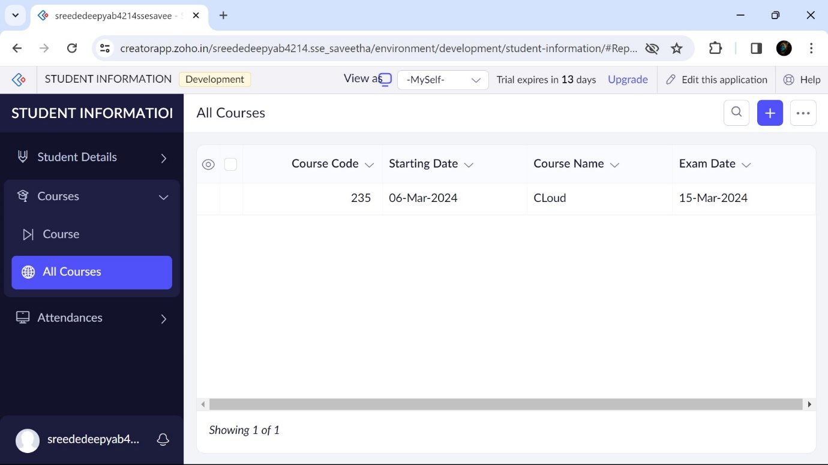

Step 7: Displaying the details entered in ‘Attendance’

